2.4 Impact analysis

Key points
- The lineage view is part of every workspace. It shows a visual representation of all the items in your workspace, showing which items are consumed by which other items (and therefore their dependencies).

- Impact analysis allows us to see the dependencies for each item in your workspace. I.e. "if I make a breaking change to item X, which downstream items will be affected.

- You also have the ability to notify people in the workspace about these changes.

Lineage View:
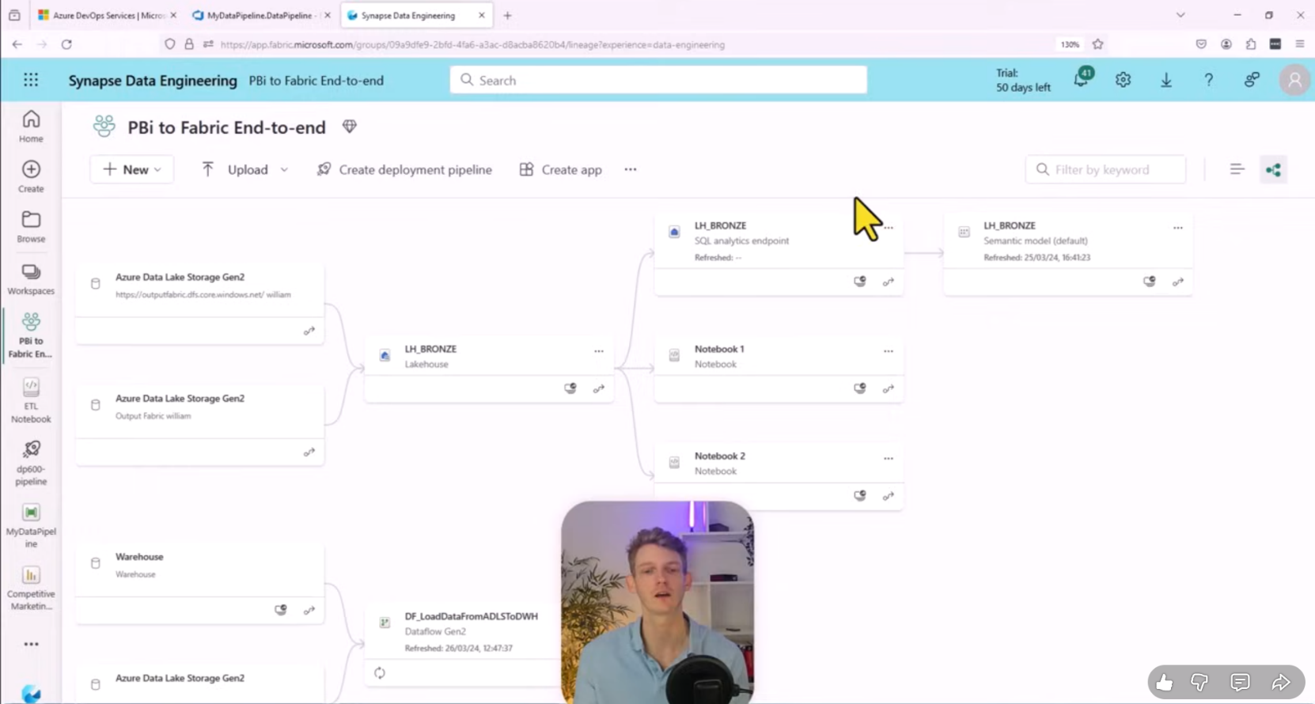

Show impact details:
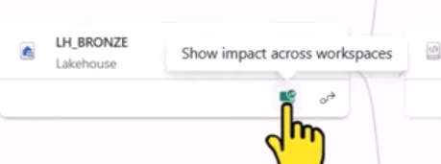

Impact analysis Beispiel (it shows impacted/downstream” items):
